Parth Babbar

know-your-customer

**Introduction:**

Know Your Customer (KYC) legislation aim to keep financial institutions from being utilised for illegal activities like money laundering, terrorist funding, and fraud. KYC entails validating consumers' identities, determining their risk levels, and monitoring their transactions. In the United States, KYC requirements are an important part of the overall anti-money laundering (AML) system.

**Regulatory Authorities:**

1. **Financial Crimes Enforcement Network (FinCEN):** FinCEN, an agency of the US Department of the Treasury, is in charge of implementing AML and KYC requirements. It develops rules, gathers and analyses financial transaction data, and works with law enforcement authorities.  
   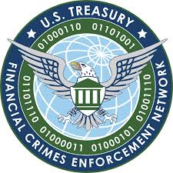
2. **Office of Foreign Assets Control (OFAC):** OFAC implements and enforces economic and trade sanctions based on US foreign policy and national security objectives. Compliance with OFAC laws is critical for doing KYC due diligence, particularly when screening consumers against sanctions lists.  
   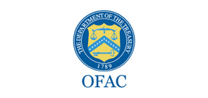
3. **Securities and Exchange Commission (SEC):** The SEC oversees securities markets and protects investors. Broker-dealers and investment advisers must establish KYC standards to avoid fraud and verify the acceptability of investment advice.  
   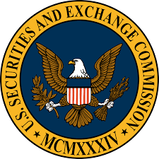
4. **Federal Reserve and Office of the Comptroller of the Currency (OCC):** These organisations supervise banks and financial institutions, ensuring compliance with KYC standards outlined in the Bank Secrecy Act (BSA) and associated AML statutes.  
   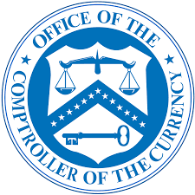 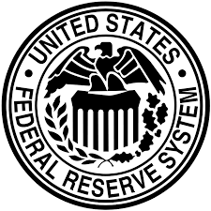

**Laws:**

1. **Patriot Act:** The Patriot Act, passed in reaction to the 9/11 attacks, extended KYC standards to improve the detection and prevention of terrorist financing. It requires client identification programmes (CIPs) and enhanced due diligence (EDD) for high-risk consumers.  
   
2. **Bank Secrecy Act:** The BSA is the cornerstone of AML rules in the United States. It requires banking institutions to keep records of cash transactions above $10,000 and to report suspicious activity to FinCEN via Suspicious Activity Reports (SARs).

There are many more laws like Anti-Money Laundering laws, customer identification program and travel rule among important ones.

**Requirements for KYC:**

1. **Documentation and Verification:** Financial institutions must create systems to collect and verify client identifying papers, including government IDs and utility bills.
2. **Risk-Based Approach:** Institutions should perform additional due diligence for high-risk customers, including politically exposed individuals (PEPs) and clients from high-risk areas.
3. **Transaction Monitoring and Reporting:** Continuous monitoring of client transactions is vital to spot and report suspicious behaviours that may suggest money laundering or other criminal behaviour.
4. **Record-Keeping:** Financial institutions must keep accurate records of customer identity, transaction histories, and KYC due diligence for regulatory scrutiny.  
   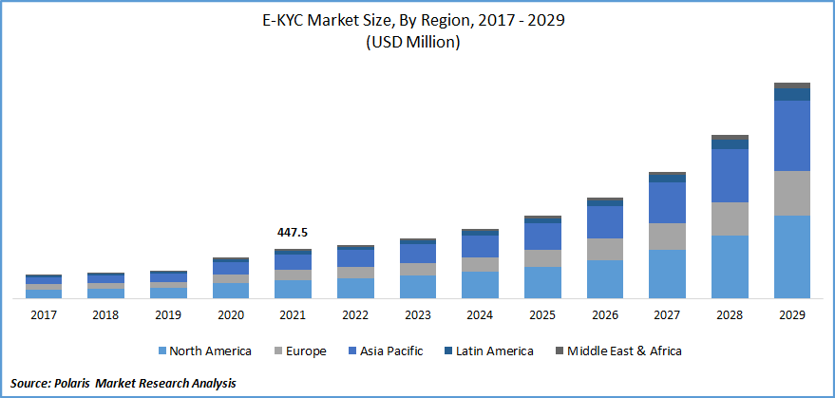

**Future Trends:**

1. **Technological Innovations:** Fintech, RegTech, and digital identity solutions will improve KYC compliance by providing efficient and secure customer identification and verification techniques.
2. **Cross-Border Compliance:** To successfully handle money laundering and terrorist financing issues, KYC requirements must be harmonised and cross-border cooperation is necessary due to globalisation.
3. **Privacy and Data Protection:** It's still difficult to strike a balance between KYC standards, consumer privacy concerns, and data protection laws, particularly in light of the growing amount of sensitive personal data being collected and shared.
4. **Regulatory Evolution:** Regulators must adjust KYC laws to meet evolving risks and technology, making compliance a strategic priority for financial firms.

**Conclusion:**

KYC requirements are critical to ensuring the integrity of the financial system and limiting the risks connected with financial crimes. Financial organisations may improve their KYC compliance efforts by adhering to regulatory standards, implementing best practices, and embracing technology advancements.